INDEX

1. INTRODUCTION
2. SITECORE CHANGES TO BE DONE
3. CONFIGURATON CHANGES IN FILES AND DEMO RENDERINGS
4. **INTRODUCTION**

This module supports Sitecore 8x Versions and is built on .Net Framework 4.5.2

This document explains the steps required to be done in Sitecore and Configuration files to be used.

Pre- requisite, Signin and Signup policies are created in AzureAD and developers are familiar with Azure AD.

First, let’s see how does it work?

When a restricted page URL is requested, it is redirected to Azure’s Sign-in Policy Page and after Sign-in verification it is redirected back to the requested page.

1. Guest user requesting the page, getting redirected to login page.

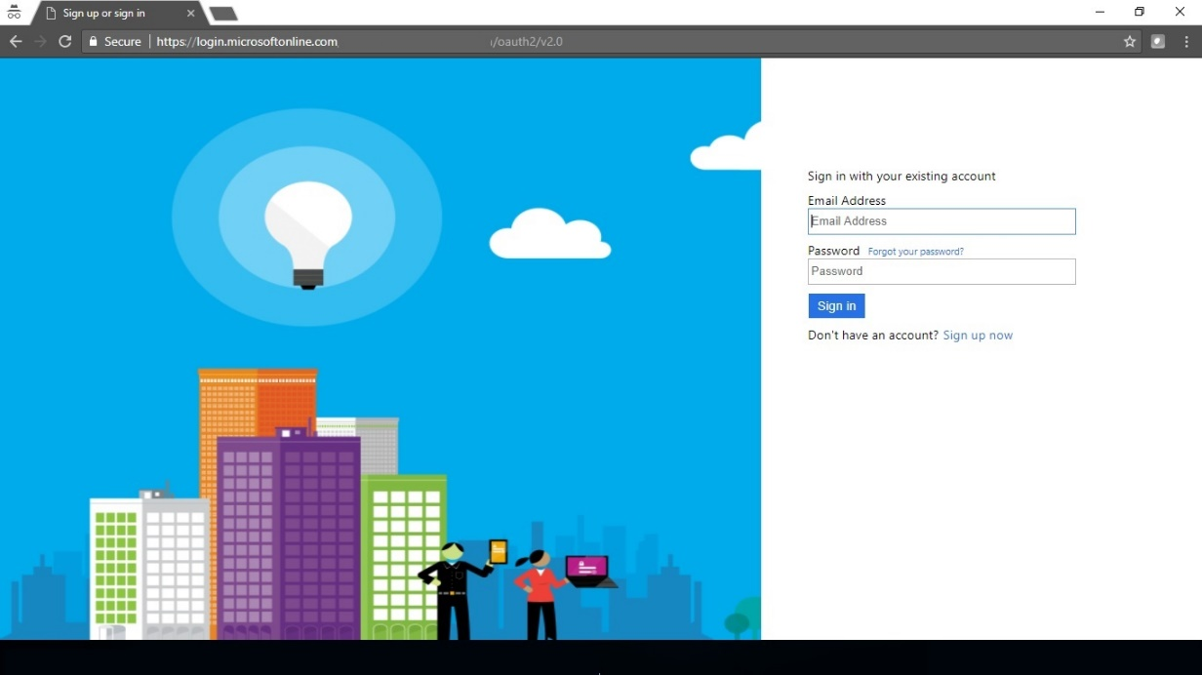

1. After login credentials are given, if multifactor authentication is enabled from Sign-in Policy of Azure, OTP will be sent to the mobile phone as shown below.



1. After OTP verification the end-user will be redirected requested page.

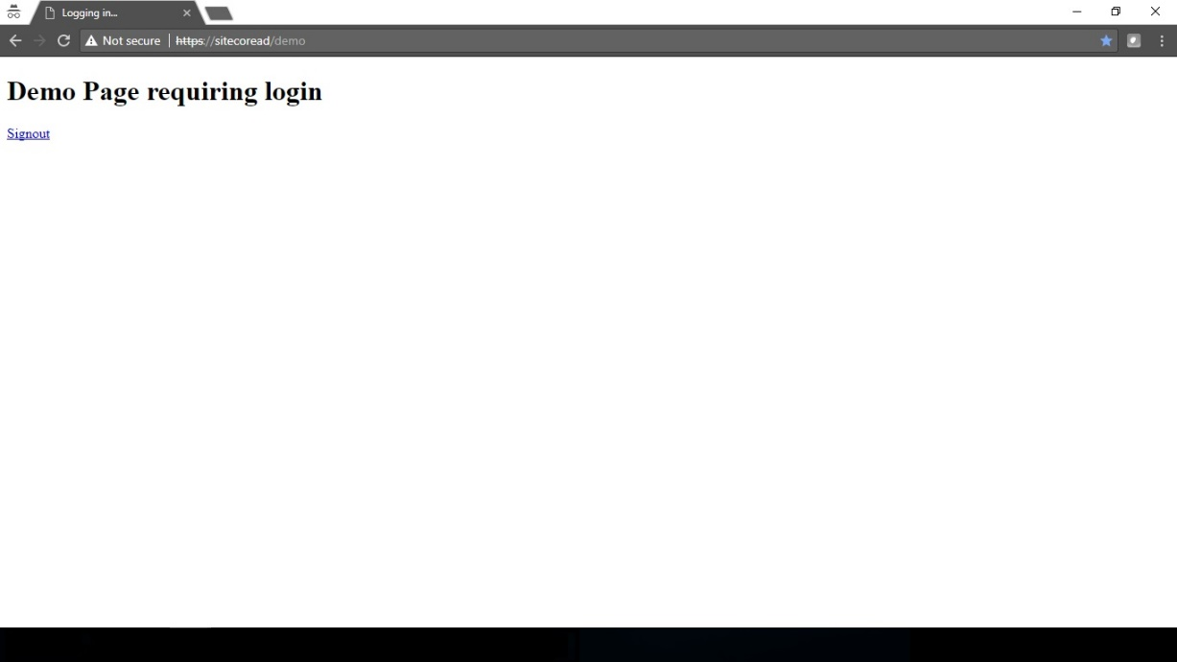

1. On clicking the Signout link enduser will be redirected back to the page item whose URL is given in “SignoutRedirectUrl” property of the Settings.cs as shown below.

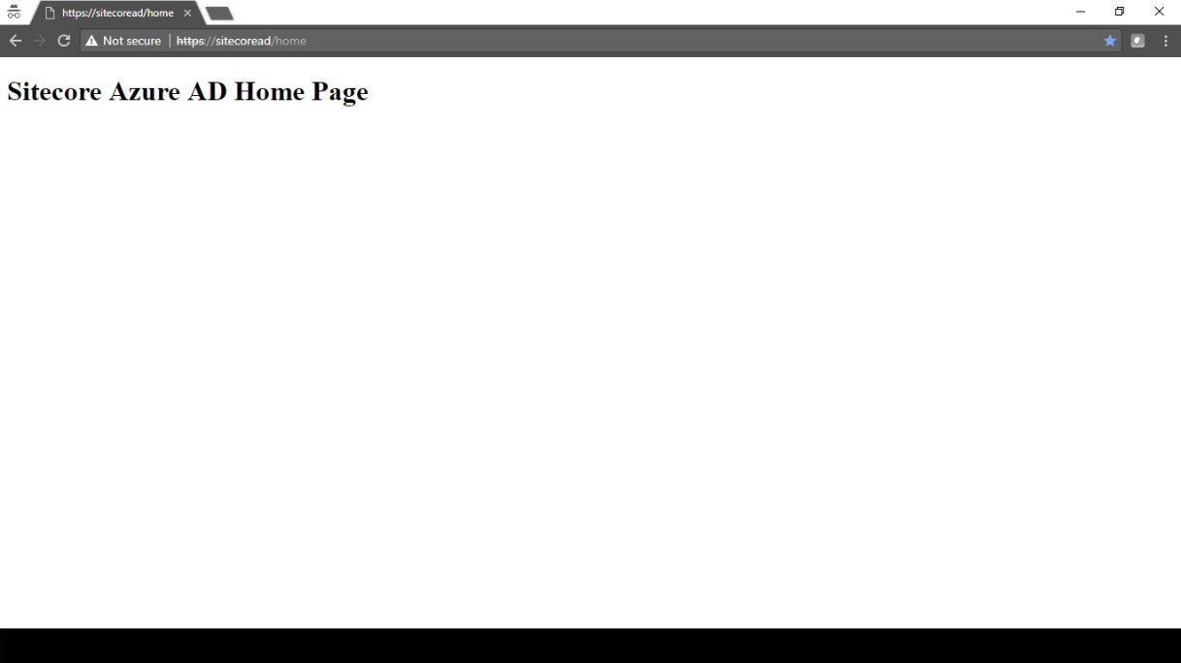

1. **SITECORE CHANGES**

Now, let’s see changes to be done in sitecore.

1. Create the domain as per your need.

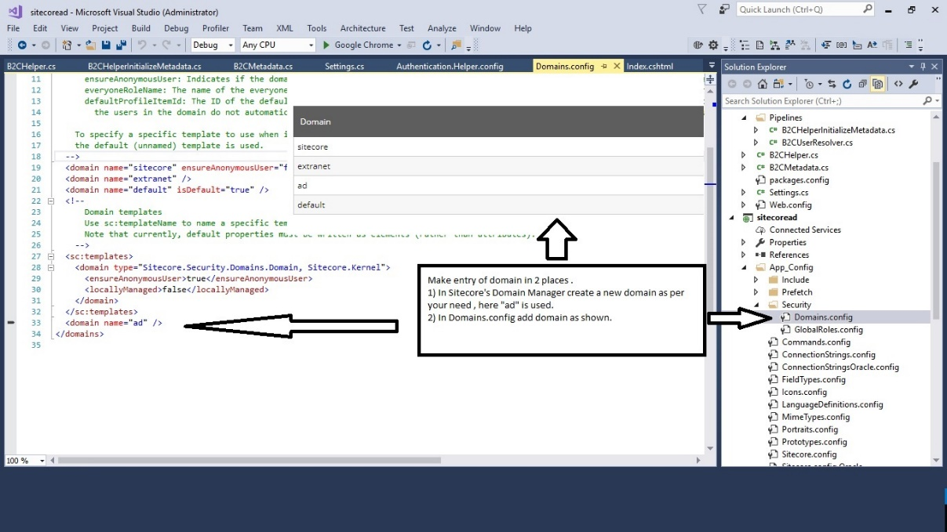

1. Apply Require Login Restriction on the restricted page item for user “extranet\Anonymous”, here it is “demo” item.

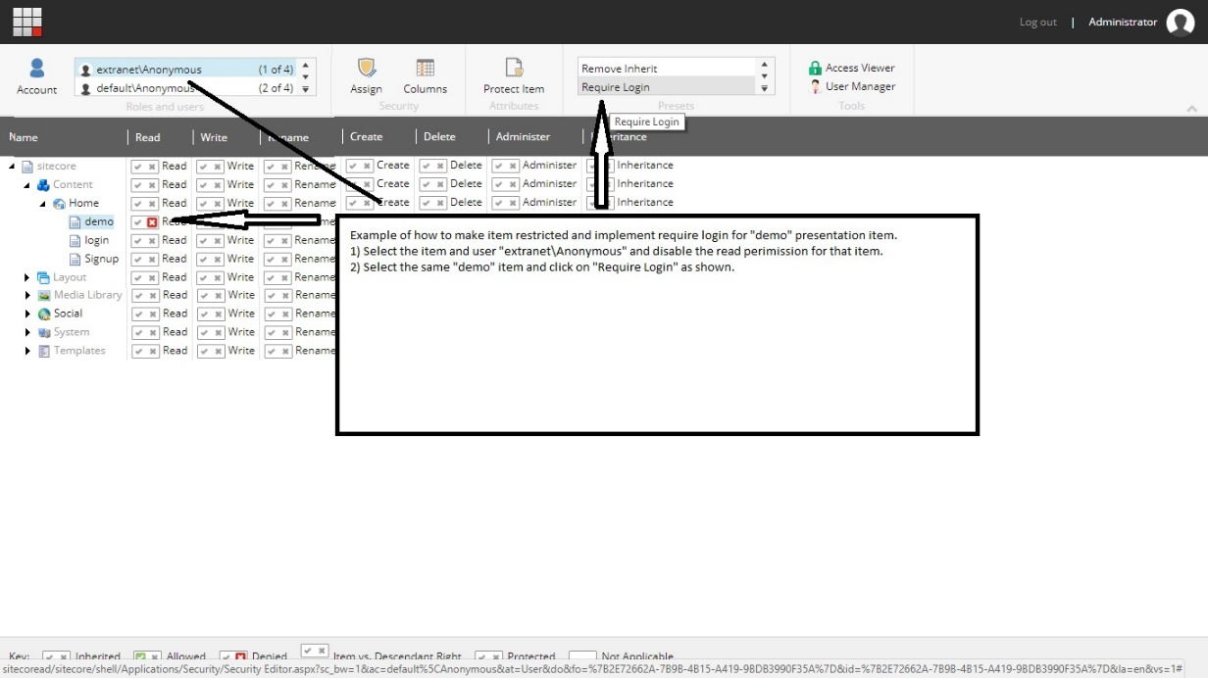

1. Apply the presentation to restricted page item as shown below, you can use any layout page here “MyLayout” is used to explain how to give Signout link on webpage.

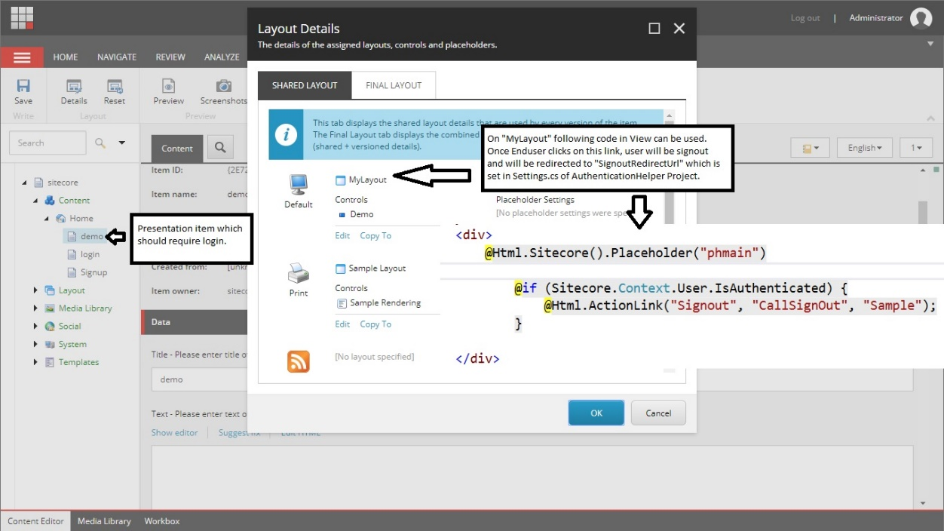

1. **CONFIGURATON CHANGES IN FILES AND DEMO RENDERINGS**
2. This module comes with two projects
3. AuthenticationHelper Project –Main Project to be added in your solution
4. Example Presentation Layer Project i.e. how to use it in your project

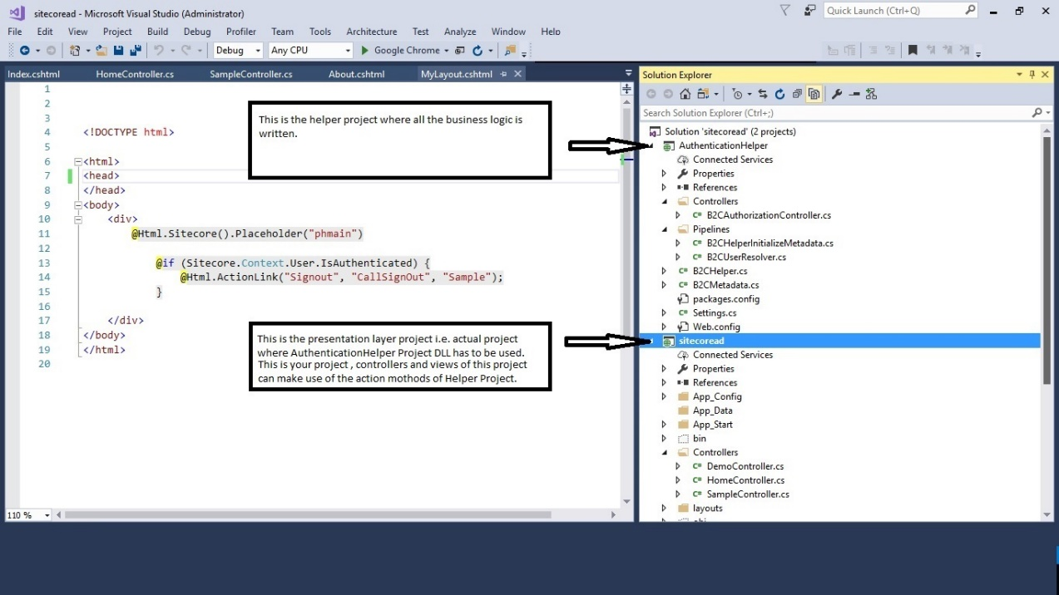

1. Add the custom patchup file “Authentication.Helper.config” under your projects AppConfig/Include folder as shown below.

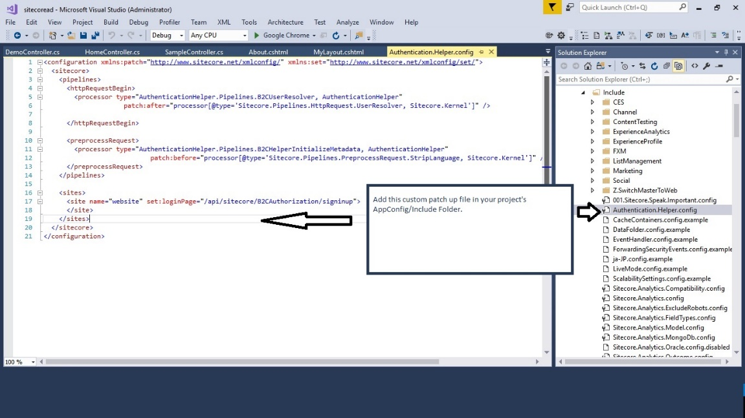

1. And obviously, add the dll of “AuthenticationHelper” project in reference of your project.

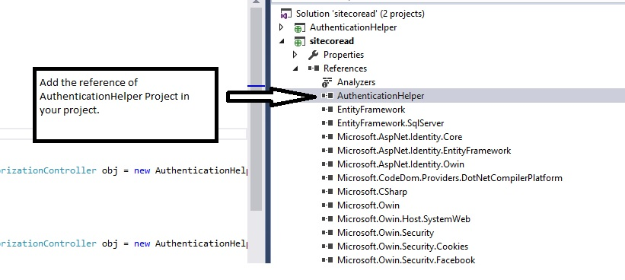

1. All the entries related with policies , endpoints, clientids etc are given “Settings.cs” fils of AuthenticationHelper Project as shown below.

